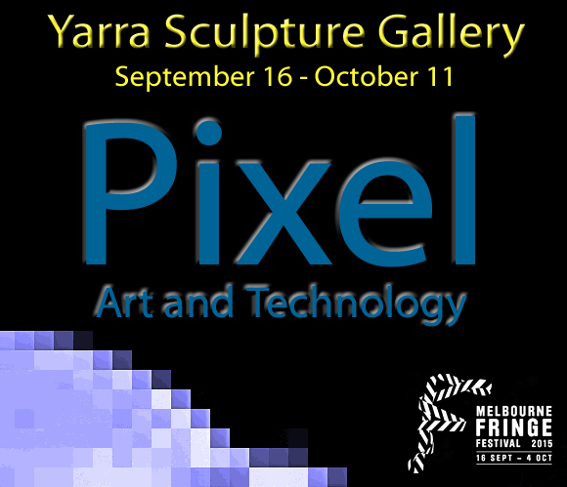

PIXEL: Art & Technology
September 16 - October 11

OPENING: Saturday September 19, 4-7pm

YSG: 117 Vere Street Abbotsford Vic 3067
Web: yarrasculpturegallery.com.au
Email: yarrasculpturegallery@gmail.com
Facebook: Yarra Sculpture Gallery: Current Projects

With such tools and devices available at our fingertips, how does
technology colour and filter artistic practice?

And how do artists create and twist technology, to expand and tilt
our visual codes, language, and identity?

INFORMATION FOR ARTISTS

Artists are invited to propose new work or a recently produced piece that responds to the above questions.

More broadly, PIXEL invites consideration to how technology mediates with art making, via various processes in which artists prepare, produce, and display new works across a diversity of creative endeavour.

Artworks for PIXEL can be submitted in any media and materials, including sculpture, installations, photography, performance events, video, sound, and light projection. There is no specific size limit to the scale of works. What is essential is prior consultation with the curator during the Expressions of Interest period (see key dates over page).

Yarra Sculpture Gallery features 5 exhibition spaces. Participating artists are primarily responsible for sourcing specific equipment and hanging systems for their artworks prior to the delivery date. YSG can offer limited installation support, where appropriate after delivery.

There is a $40 fee to exhibit. No commission is taken on the sale of works. New works made for PIXEL, or produced within the last 2 years is preferred.

Interested applicants are strongly recommended to inspect YSG prior to submitting a proposal. A plan view of the gallery can be accessed here:
http://www.yarrasculpturegallery.com.au/show-with-us.html
Artists must submit the following information to YSG via email by September 4:

- A word document with your primary details: name, email, postal address, phone number and artist website/ online page
- Artist CV, or brief biography, including recent shows and projects
- Artwork Information: Title, date, medium, scale/ dimensions, and price
- An artist statement (max. 250 words) about the proposed work.
* This statement includes how your artwork relates to PIXEL.
- 1-3 good quality digital images of the proposed artworks, or video/ sound grab, where appropriate. Digital photos are preferred at 1MB in size or less.
- Clear instructions of how the artwork will to be installed, displayed, and managed during the exhibition, where applicable.

On Delivery, artworks for PIXEL must be:

- An original work by the artist
- Labelled with the artists name, contact number, and artwork information
- Ready to be installed safely, with appropriate resources needed and instructions as required
- Confirm the $40 fee payment. Payments can be made online, or at YSG

Yarra Sculpture Gallery reserves the right to decline artworks on delivery that is unsafe for exhibition, or does not meet the above delivery requirements. Fee receipts are available on delivery with proof of payment. Online Payments made to the Contemporary Sculptors Association: B. 06 3266 A/C. 1001 3538

PLEASE NOTE: Eft-Pos is not available at YSG

KEY DATES
Expressions of Interest
Open: Friday July 24 - Close: Friday August 28
All E.O.I. enquiries to Paul Gorman: via gallery email to PIXEL @YSG

Submission Deadline
Friday 4 September
Applications must be emailed to PIXEL @YSG: yarrasculpturegallery@gmail.com

Delivery of Artwork
Artists are required to deliver completed artworks to Yarra Sculpture Gallery on:
Saturday 12 September, or Sunday 13 September from 12-5pm

Opening Night
Saturday 19 September 2015, 4 – 7pm
Exhibition Dates
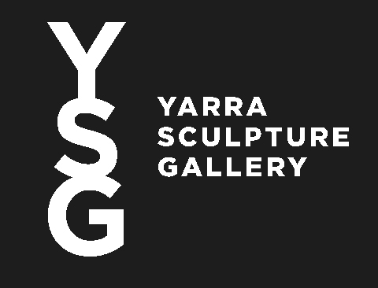
Wednesday 16 September – Sunday October 11 2015

Collection of Work
Sunday October 11, 5-7pm
*Further pick-up times on October 12-14 to be announced

